Control Structure
26-10-25
Aim – Implement a program to demonstrate control structure, write code to check whether it is Armstrong, generate Fibonacci series, LCM, GCD and grading system.
Theory –
If - Executes a block of code only when a specified condition evaluates to true, enabling decision-making in programs.
Else if - Checks multiple conditions sequentially; executes the first true condition’s block, providing more flexible decision-making than simple if.
While - Repeats a block of code as long as a specified condition remains true, enabling controlled iteration.
Break - Immediately exits the nearest enclosing loop or switch, stopping further iterations or case execution prematurely.
A1.
#include"stdio.h"
void main()
{
int n,count=0,result=0,mul=1,cnt,rem;
printf("Armstrong Numbers\n");
printf("enter a number:");
scanf("%d",&n);
int q=n;
while(q!=0){
q=q/10;
count++;
}
cnt=count;
q=n;
while(q!=0){
rem=q%10;
while(cnt!=0){
mul= mul*rem;
cnt--;
}
result = result+mul;
cnt = count;
q = q/10;
mul = 1;
}
if(result==n){
printf("%d is an armstrong number",n);
} else {
printf("%d is an not armstrong number",n);
}
}
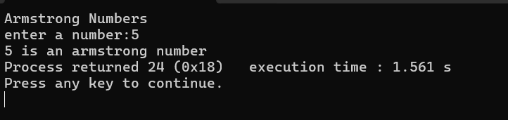
A2.
#include <stdio.h>
void main(){
int a=0,b=1,c,i,n;
printf("Enter a number:");
scanf("%d",&n);
printf("Fibonacci series \n0\n1\n");
for(i=1; i<=n-2;i++){
c=a+b;
printf("%d\n",c);
a=b;
b=c;
}
}
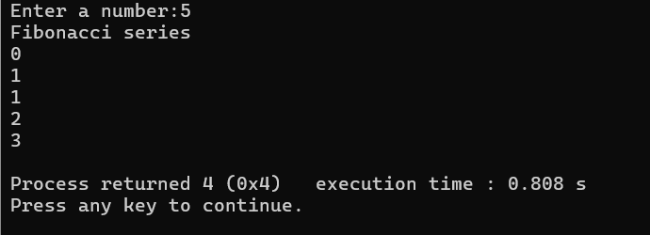
A3.
#include <stdio.h>
void main()
{
int num1, num2, lcm;
printf("LCM\n");
printf("Enter first number: ");
scanf("%d", &num1);
printf("Enter second number: ");
scanf("%d", &num2);
lcm = (num1 > num2) ? num1 : num2;
while (1) {
if (lcm % num1 == 0 && lcm % num2 == 0){
printf("The LCM of %d and %d is %d.\n", num1, num2, lcm);
break;
}
lcm++;
}
}
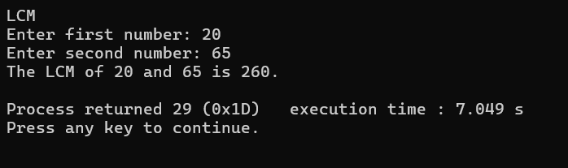
A4.
#include <stdio.h>
void main()
{
int n1,n2,gcd;
printf("GCD\n");
printf("Enter first number:");
scanf("%d", &n1);
printf("Enter second number:");
scanf("%d", &n2);
if(n1<n2){
gcd=n1;
} else {
gcd=n2;
}
while(n1% gcd!=0 || n2% gcd!=0){
gcd --;
}
if(gcd==1){
printf("GCD doesn't exist");
} else {
printf("GCD= %d",gcd);
}
}
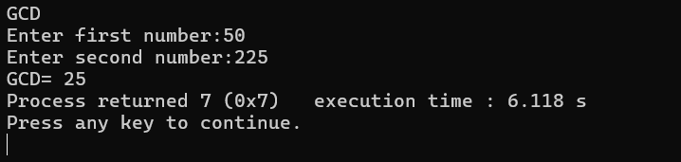
A5.
#include"stdio.h"
void main()
{
int marks;
printf("Enter your marks (0 - 100): ");
scanf("%d", &marks);
if (marks >= 90 && marks <= 100)
printf("Grade: A\n");
else if (marks >= 80)
printf("Grade: B\n");
else if (marks >= 70)
printf("Grade: C\n");
else if (marks >= 60)
printf("Grade: D\n");
else if (marks >= 50)
printf("Grade: E\n");
else if (marks >= 0)
printf("Grade: F (Fail)\n");
else
printf("Invalid marks entered.\n");
}
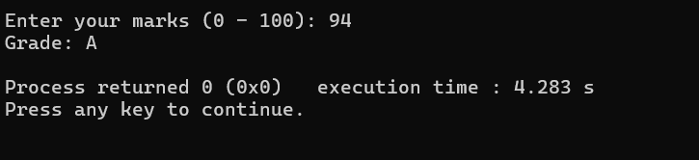
Conclusion
Through this assignment, we explored various control structures like if, else if, while, and break to solve real-world problems. By implementing programs for Armstrong numbers, Fibonacci series, LCM, GCD, and grading, we learned how decision-making and iteration form the backbone of logical programming, enhancing problem-solving skills effectively.

